Eritrea

## Respect for rule of law (ROL) data

The data set shows the data on the respect of the rule of law for the country.

## # A tibble: 19 x 5  
## country iso3c date ruleOfLaw ruleOfLawCategory4   
## <chr> <chr> <dbl> <dbl> <chr>   
## 1 Eritrea ERI 1996 -0.655 ROL moderately disrespected  
## 2 Eritrea ERI 1998 -0.424 ROL moderately disrespected  
## 3 Eritrea ERI 2000 -0.564 ROL moderately disrespected  
## 4 Eritrea ERI 2002 -0.562 ROL moderately disrespected  
## 5 Eritrea ERI 2003 -0.658 ROL moderately disrespected  
## 6 Eritrea ERI 2004 -0.864 ROL moderately disrespected  
## 7 Eritrea ERI 2005 -1.04 ROL highly disrespected   
## 8 Eritrea ERI 2006 -1.19 ROL highly disrespected   
## 9 Eritrea ERI 2007 -1.28 ROL highly disrespected   
## 10 Eritrea ERI 2008 -1.30 ROL highly disrespected   
## 11 Eritrea ERI 2009 -1.31 ROL highly disrespected   
## 12 Eritrea ERI 2010 -1.35 ROL highly disrespected   
## 13 Eritrea ERI 2011 -1.35 ROL highly disrespected   
## 14 Eritrea ERI 2012 -1.39 ROL highly disrespected   
## 15 Eritrea ERI 2013 -1.41 ROL highly disrespected   
## 16 Eritrea ERI 2014 -1.53 ROL highly disrespected   
## 17 Eritrea ERI 2015 -1.49 ROL highly disrespected   
## 18 Eritrea ERI 2016 -1.63 ROL highly disrespected   
## 19 Eritrea ERI 2017 -1.56 ROL highly disrespected

## Respect for rule of law (ROL) trend

The plot shows the trend of the respect for the rule of law for the country.

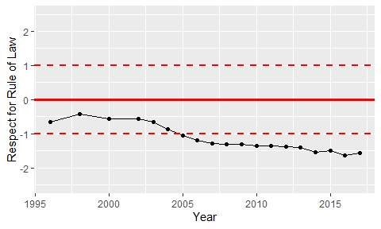

Trend of the Respect for the Rule of Law